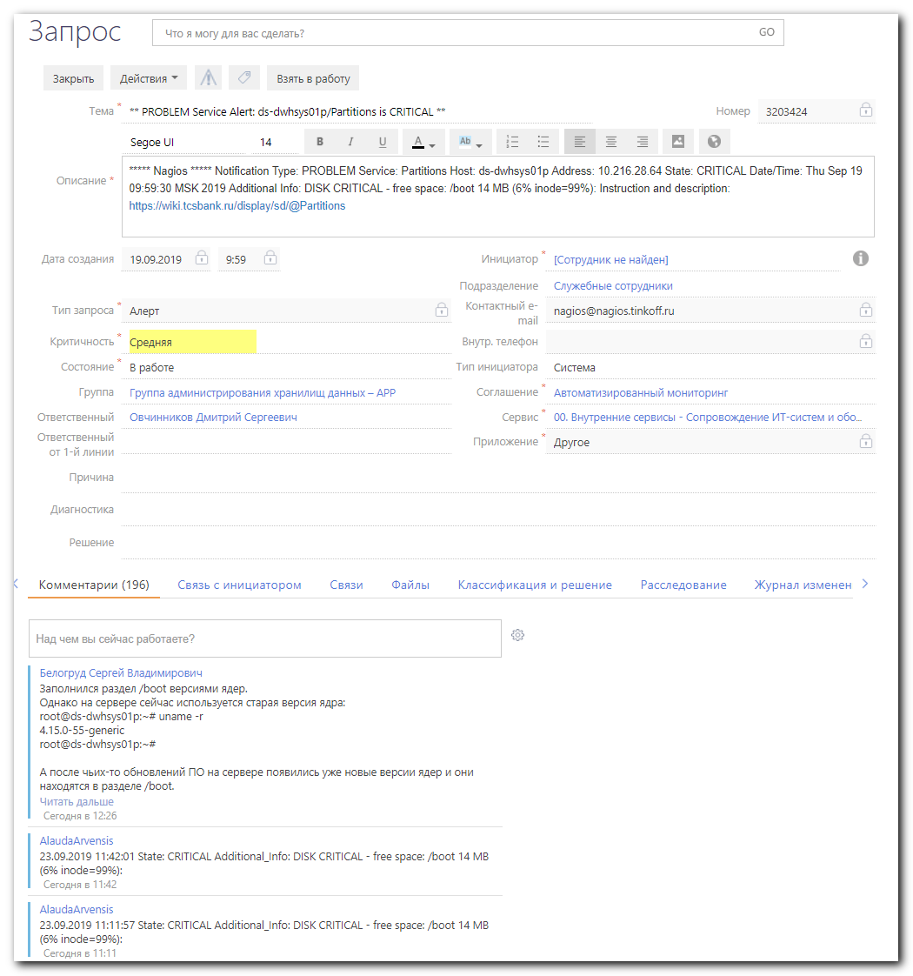

Заполнился раздел /boot версиями ядер.
Однако на сервере сейчас используется старая версия ядра:
root@ds-dwhsys01p:~# uname -r
4.15.0-55-generic
root@ds-dwhsys01p:~#

А после чьих-то обновлений ПО на сервере появились уже новые версии ядер и они находятся в разделе /boot.
Перезагрузите сервер, чтобы переключиться на использование новой версии ядер. И тогда старые версии ядер удалите.
Нашел статью, где описаны подробности:
https://linoxide.com/booting/remove-old-kernel-versions-boot-menu/
https://www.cyberciti.biz/faq/ubuntu-18-04-remove-all-unused-old-kernels/

root@ds-dwhsys01p:~# cat /etc/os-release
NAME="Ubuntu"
VERSION="18.04.2 LTS (Bionic Beaver)"
ID=ubuntu
ID_LIKE=debian
PRETTY_NAME="Ubuntu 18.04.2 LTS"
VERSION_ID="18.04"
HOME_URL="https://www.ubuntu.com/"
SUPPORT_URL="https://help.ubuntu.com/"
BUG_REPORT_URL="https://bugs.launchpad.net/ubuntu/"
PRIVACY_POLICY_URL="https://www.ubuntu.com/legal/terms-and-policies/privacy-policy"
VERSION_CODENAME=bionic
UBUNTU_CODENAME=bionic
root@ds-dwhsys01p:~#

root@ds-dwhsys01p:~# lsblk
NAME MAJ:MIN RM SIZE RO TYPE MOUNTPOINT
loop0 7:0 0 86.9M 1 loop /snap/core/4917
sda 8:0 0 30G 0 disk
├─sda1 8:1 0 1M 0 part
├─sda2 8:2 0 256M 0 part /boot
└─sda3 8:3 0 29.8G 0 part
└─vg_root-lvol0 253:0 0 29.8G 0 lvm /
sr0 11:0 1 1024M 0 rom
root@ds-dwhsys01p:~#

root@ds-dwhsys01p:~# df -hT /boot
Filesystem Type Size Used Avail Use% Mounted on
/dev/sda2 ext4 240M 209M 15M 94% /boot
root@ds-dwhsys01p:~#

root@ds-dwhsys01p:~# ls -Alh /boot
total 200M
-rw-r--r-- 1 root root 213K Jul 2 16:41 config-4.15.0-55-generic
-rw-r--r-- 1 root root 213K Sep 4 20:11 config-4.15.0-62-generic
-rw-r--r-- 1 root root 213K Sep 12 09:30 config-4.15.0-64-generic
drwxr-xr-x 5 root root 1.0K Sep 22 06:24 grub
-rw-r--r-- 1 root root 55M Jul 28 06:06 initrd.img-4.15.0-55-generic
-rw-r--r-- 1 root root 55M Sep 19 06:46 initrd.img-4.15.0-62-generic
-rw-r--r-- 1 root root 55M Sep 22 06:24 initrd.img-4.15.0-64-generic
drwx------ 2 root root 12K Jan 17 2019 lost+found
-rw------- 1 root root 3.9M Jul 2 16:41 System.map-4.15.0-55-generic
-rw------- 1 root root 3.9M Sep 4 20:11 System.map-4.15.0-62-generic
-rw------- 1 root root 3.9M Sep 12 09:30 System.map-4.15.0-64-generic
-rw------- 1 root root 8.0M Jul 2 18:03 vmlinuz-4.15.0-55-generic
-rw------- 1 root root 8.0M Sep 4 20:16 vmlinuz-4.15.0-62-generic
-rw------- 1 root root 8.0M Sep 12 12:38 vmlinuz-4.15.0-64-generic
root@ds-dwhsys01p:~#

root@ds-dwhsys01p:~# uname -r
4.15.0-55-generic
root@ds-dwhsys01p:~#

root@ds-dwhsys01p:~# dpkg -l | grep -E 'linux-image-[0-9]+' | grep -Fv $(uname -r)
rc linux-image-4.15.0-54-generic 4.15.0-54.58 amd64 Signed kernel image generic
rc linux-image-4.15.0-58-generic 4.15.0-58.64 amd64 Signed kernel image generic
rc linux-image-4.15.0-60-generic 4.15.0-60.67 amd64 Signed kernel image generic
ii linux-image-4.15.0-62-generic 4.15.0-62.69 amd64 Signed kernel image generic
ii linux-image-4.15.0-64-generic 4.15.0-64.73 amd64 Signed kernel image generic
root@ds-dwhsys01p:~#

root@ds-dwhsys01p:~# uptime
09:20:58 up 55 days, 21:28, 1 user, load average: 0.00, 0.00, 0.00
root@ds-dwhsys01p:~#

https://linoxide.com/booting/remove-old-kernel-versions-boot-menu/

How to Remove Old kernel Versions from Boot on Ubuntu 18.04
Updated July 24, 2019BOOTING, LINUX HOWTO
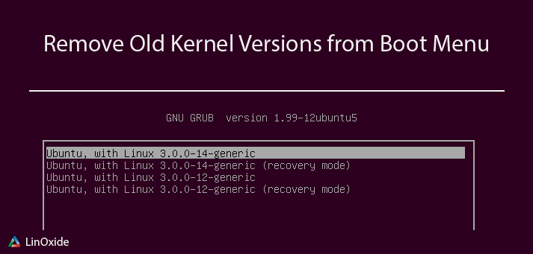
Canonical provides regular updates for Ubuntu 18.04 system including kernel updates to manage the system’s resources as best as possible. This article will provide you some different methods to remove old kernels from the boot menu of your Ubuntu 18.04. When you install a new kernel, the old ones are not deleted because it can help you to boot if you do a mistake with the new one or for some other reason. Notice that the old kernel consume some spaces which can be useful for something else. We sometimes need to update the kernel for compatibilities because it is responsible for interfacing all of the applications.
Table of Contents
- Check for old kernels
- 1) Remove old kernels in command line
  - a) apt command
  - b) dpkg command
  - c) Using a script
- 2) Use graphical tools to remove old kernels
  - a) Ubuntu cleaner
  - b) Synaptic
- Conclusion
  - Read also

Check for old kernels
In order to avoid any mistakes with the current boot kernel of your Ubuntu 18.04 system, make sure to check its version
# uname -r
4.15.0-23-generic
Before trying to remove the old kernel, you must first check if there are old kernels presents in the systems. To do that, you can look at the grub when the system startups
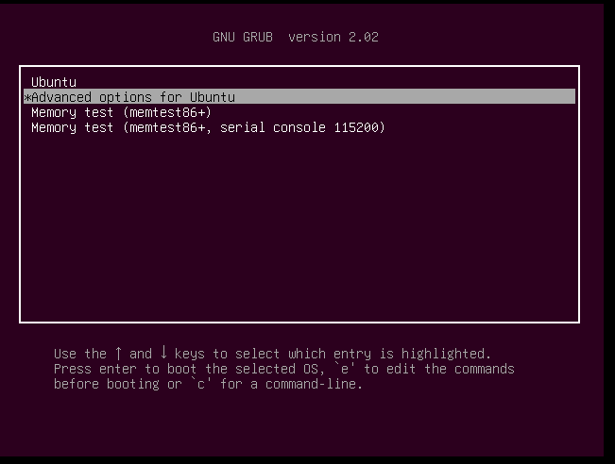
you can select "advanced option for Ubuntu". You can see the current kernel on the top of the list with the old kernel one just following 4.15.0.13-generic
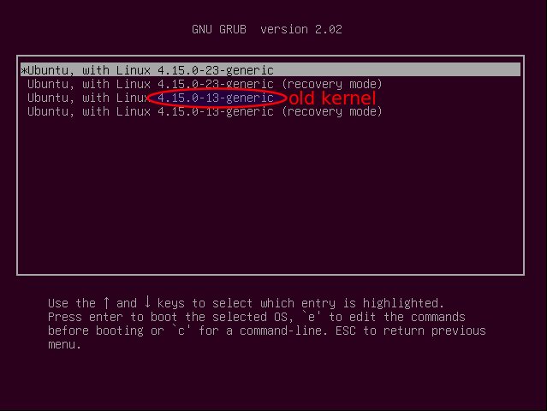
There is another method to check the old kernel in the command line. This will help you to list the old kernel and not the current one
# dpkg -l | grep -E 'linux-image-[0-9]+' | grep -Fv $(uname -r)
ii linux-image-4.15.0-13-generic 4.15.0-13.14 amd64 Linux kernel image for version 4.15.0 on 64 bit x86 SMP
You can see that you effectively have an old kernel installed marked with ii. You can see more old kernels if you have done some upgrade or manual installation. There is some status when you check the kernel
- ii: means that the kernel/packages are installed and eligible for removal.
- rc: indicates that the kernel has already been removed.
- iU: is something like a warning tells to DON’T REMOVE. That means not installed but queued for install in apt.
Make sure to see the status before doing anything. Now that we have found some kernels installed, now let's see the different methods to remove each or the totality.

1) Remove old kernels in command line
There are some useful commands to remove the old kernels whether you have installed it manually or directly via the system updates. Normally you install it via the regular system updates but for some reasons, you can decide to do a manual installation.

a) apt command
The apt command help to uninstall packages including the old kernels that you don't need in your Ubuntu 18.04 systems. You can check the ones which were automatically installed as below
# apt-mark showauto 'linux-image-.*'
linux-image-4.15.0-13-generic
linux-image-4.15.0-23-generic
linux-image-extra-4.15.0-13-generic
linux-image-generic
and you can check those that were manually installed as below
# apt-mark showmanual 'linux-image-.*'
As you can see, we don't have any kernel manually installed. You can remove all the old kernel with the remove parameter as below:
# apt remove linux-image-4.15.0-13-generic
Reading package lists... Done
Building dependency tree
Reading state information... Done
The following packages will be REMOVED:
linux-image-4.15.0-13-generic* linux-image-extra-4.15.0-13-generic
....
....
you may need to re-run your boot loader[grub]
When you remove a kernel, make sure to update the grub to see if any error occurs while generating the grub
# update-grub
Generating grub configuration file ...
Found linux image: /boot/vmlinuz-4.15.0-23-generic
Found initrd image: /boot/initrd.img-4.15.0-23-generic
Found memtest86+ image: /boot/memtest86+.elf
Found memtest86+ image: /boot/memtest86+.bin
done
Now you can check again if it has been removed
# dpkg -l | grep -E 'linux-image-[0-9]+' | grep -Fv $(uname -r)
rc linux-image-4.15.0-13-generic 4.15.0-13.14 amd64 Linux kernel image for version 4.15.0 on 64 bit x86 SMP
You can see the status rc which show that it's has been removed. You can check also on the boot menu and see that only the current boot kernel appear
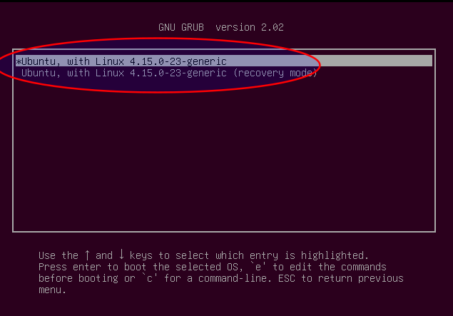
You can also use the apt autoremove command but you should notice that the command is used to remove packages that were automatically installed to satisfy dependencies for other packages and are no longer needed as dependencies. So check if there is not a package that you need present in the list of packages to remove
# apt autoremove --purge

b) dpkg command
You can also use the dpkg command to remove a specific kernel on your Ubuntu 18.04 system. This time you will need to indicate package and the extra dependencies
# dpkg --purge linux-image-4.15.0-13-generic linux-image-extra-4.15.0-13-generic
(Reading database ... 165680 files and directories currently installed.)
...
...
Generating grub configuration file ...
Found linux image: /boot/vmlinuz-4.15.0-23-generic
Found initrd image: /boot/initrd.img-4.15.0-23-generic
Found memtest86+ image: /boot/memtest86+.elf
Found memtest86+ image: /boot/memtest86+.bin
done
...

You can check again the traces but you will see there are completely removed because you will not have an output showing that it has been removed (rc)
# dpkg -l | grep -E 'linux-image-[0-9]+' | grep -Fv $(uname -r)
You can also look the grub


c) Using a script
We have found an interesting interactive script of Kivisade on Github which helps you to remove the old kernels. It uses the dpkg command but the interesting thing is the fact that it lists the kernels to remove and asks your opinion. First install git
# apt install git
Now clone the project
# git clone https://github.com/kivisade/kernel-purge.git
Cloning into 'kernel-purge'...
remote: Counting objects: 3, done.
remote: Total 3 (delta 0), reused 0 (delta 0), pack-reused 3
Unpacking objects: 100% (3/3), done.
enter to the folder and give the permission
# cd kernel-purge && chmod +x kernel-purge.sh
Now run the script
# ./kernel-purge.sh
Running kernel version is: 4.15.0-23
The following (unused) KERNEL packages will be removed:
linux-headers-4.15.0-13
linux-headers-4.15.0-13-generic
linux-image-4.15.0-13-generic
linux-image-extra-4.15.0-13-generic
Do you want to continue [yN]? y
Reading package lists... Done
Building dependency tree
Reading state information... Done
The following packages will be REMOVED:
linux-headers-4.15.0-13* linux-headers-4.15.0-13-generic*
linux-image-4.15.0-13-generic* linux-image-extra-4.15.0-13-generic*
0 upgraded, 0 newly installed, 4 to remove and 0 not upgraded.
After this operation, 335 MB disk space will be freed.
(Reading database ... 168812 files and directories currently installed.)
...
...
Generating grub configuration file ...
Found linux image: /boot/vmlinuz-4.15.0-23-generic
Found initrd image: /boot/initrd.img-4.15.0-23-generic
Found memtest86+ image: /boot/memtest86+.elf
Found memtest86+ image: /boot/memtest86+.bin
done
...
...
Now you can check if the kernels have been effectively removed. You will not have an output so old kernels have been removed
# dpkg -l | grep -E 'linux-image-[0-9]+' | grep -Fv $(uname -r)

2) Use graphical tools to remove old kernels
You can also use the graphical tool to uninstall the kernel packages. The tool will ask for your password during the process because you need to have the administrative permission.

a) Ubuntu cleaner
Ubuntu Cleaner is a user-friendly system utility designed to clean browser caches, removed unneeded apps, and get shot of old kernels. Ubuntu can be helpful if you want to remove:
- Application caches which include most major browsers
- Apt cache
- Old kernel
- Unneeded packages
The package is not present by default in the official repository so we need to add the PPA. Remember that on Ubuntu 18.04 you don't need to update the packages cache after adding the PPA because it's automatically launched. So add the PPA as below
~# add-apt-repository ppa:gerardpuig/ppa
Official Ubuntu Cleaner stable repository
More info: https://launchpad.net/~gerardpuig/+archive/ubuntu/ppa
Press [ENTER] to continue or Ctrl-c to cancel adding it.

Hit:1 http://cm.archive.ubuntu.com/ubuntu bionic InRelease
Get:2 http://cm.archive.ubuntu.com/ubuntu bionic-updates InRelease [83.2 kB]
Get:3 http://security.ubuntu.com/ubuntu bionic-security InRelease [83.2 kB]
Get:4 http://cm.archive.ubuntu.com/ubuntu bionic-backports InRelease [74.6 kB]
Get:5 http://security.ubuntu.com/ubuntu bionic-security/main amd64 DEP-11 Metadata [204 B]
...
...
Now you can install the tool
# apt install ubuntu-cleaner
Reading package lists... Done
Building dependency tree
Reading state information... Done
The following additional packages will be installed:
libpython-stdlib python python-apt python-aptdaemon
...
...
Then launch the software
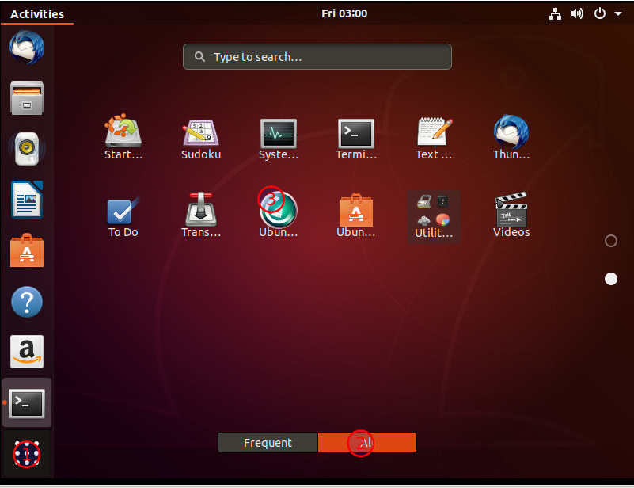
Then choose the old kernel section and select the kernels to remove
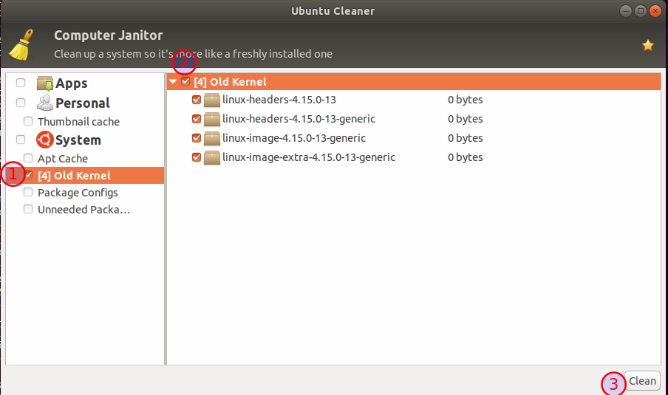
You will be asked for the password and the process will start
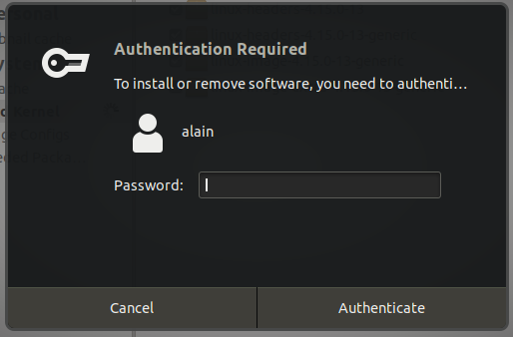
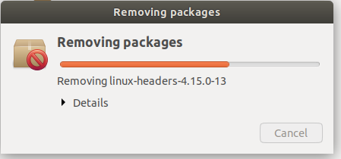
Now you can check if the kernels are still present. You can see the status which indicates that it's removed
# dpkg -l | grep -E 'linux-image-[0-9]+' | grep -Fv $(uname -r)
rc linux-image-4.15.0-13-generic 4.15.0-13.14 amd64 Linux kernel image for version 4.15.0 on 64 bit x86 SMP

b) Synaptic
Synaptic is a graphical interface to the Advanced Packaging Tool (APT) used by Debian based system to handle the installation of the packages/softwares. It isn't a user-friendly tool so it can be very confusing to use, that is why you have to be very careful.
# apt install synaptic
Reading package lists... Done
Building dependency tree
Reading state information... Done
The following additional packages will be installed:
docbook-xml libept1.5.0 libgtk2-perl libpango-perl librarian0 rarian-compat
sgml-base sgml-data xml-core
Now launch the application
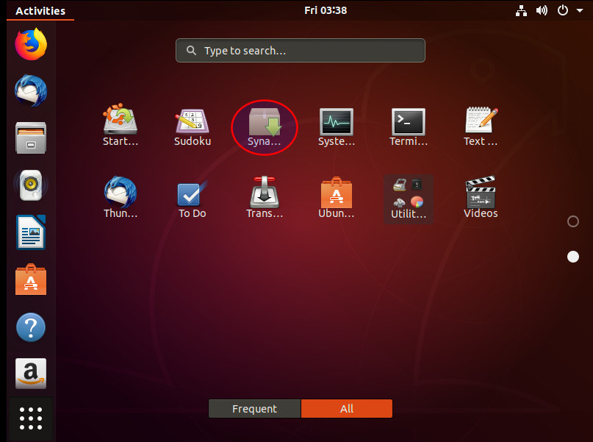
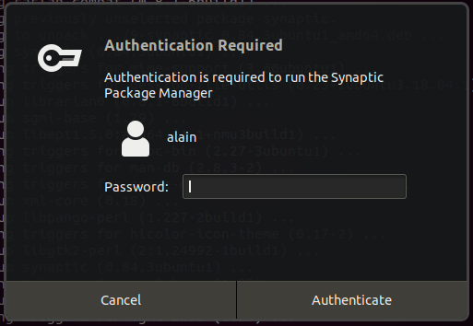
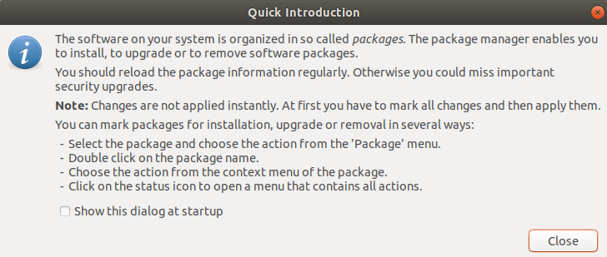
Now move to Section -> Kernel and Modules, choose the kernels to remove and mark for a complete removal. Make sure to choose the right kernels on the list
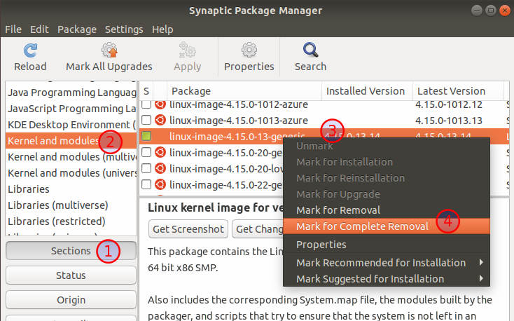
It will ask your confirmation
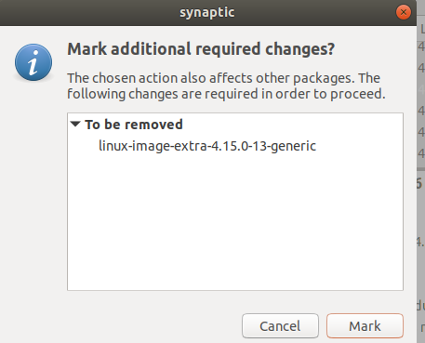
You can see that it automatically marks the dependency. Apply to remove the kernels
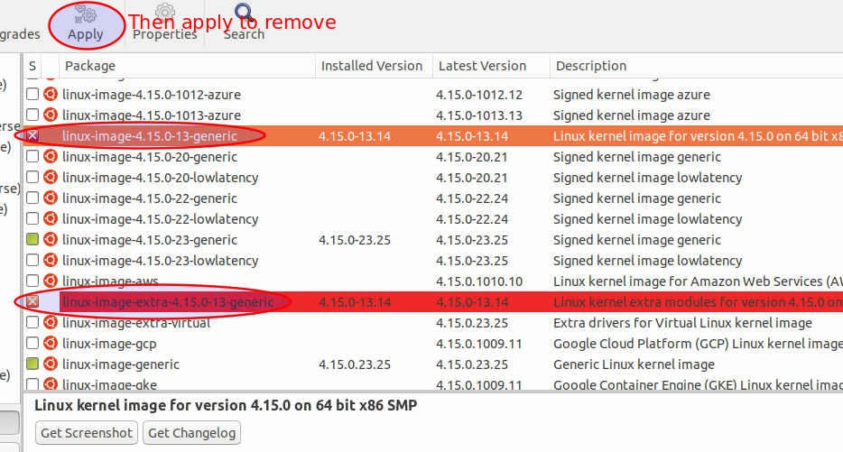
It will ask for the confirmation. Apply
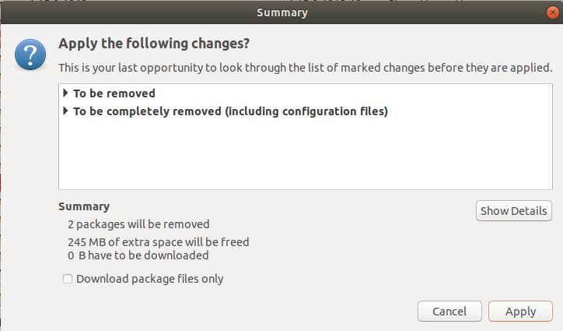
You can see a windows showing the process. If you look carefully, you will see at the end that the grub has been generated and the old kernels are not presents.
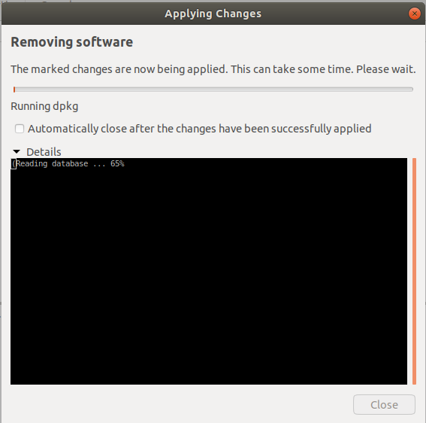

Conclusion
Now you know how you can remove the old kernel from the boot of your Ubuntu 18.04. You should notice that it's recommended to delete all the old kernel because if you are not able to boot with your current kernel for whatever reason. So it recommended to keep at least two or preferably three kernels including the latest. The reason for the recommendation is that you will have at least one or two other kernels to boot with.

Read also
- How to Use BCC Kernel Tracing Tools for Linux Performance Analysis
- How to Remove and Add PPA on Ubuntu 18.04
- 6 Commands to Clear Linux Terminal

#
# About 14.04 - 16.04.
#
https://gist.github.com/ipbastola/2760cfc28be62a5ee10036851c654600

Safest way to clean up boot partition - Ubuntu 14.04LTS-x64, Ubuntu 16.04LTS-x64
Reference

Case I: if /boot is not 100% full and apt is working

1. Check the current kernel version
$ uname -r

It will shows the list like below:
3.19.0-64-generic

2. Remove the OLD kernels

2.a. List the old kernel
$ sudo dpkg --list 'linux-image*'|awk '{ if ($1=="ii") print $2}'|grep -v `uname -r`

You will get the list of images something like below:
linux-image-3.19.0-25-generic
linux-image-3.19.0-56-generic
linux-image-3.19.0-58-generic
linux-image-3.19.0-59-generic
linux-image-3.19.0-61-generic
linux-image-3.19.0-65-generic
linux-image-extra-3.19.0-25-generic
linux-image-extra-3.19.0-56-generic
linux-image-extra-3.19.0-58-generic
linux-image-extra-3.19.0-59-generic
linux-image-extra-3.19.0-61-generic

2.b. Now its time to remove old kernel one by one as
$ sudo apt-get purge linux-image-3.19.0-25-generic
$ sudo apt-get purge linux-image-3.19.0-56-generic
$ sudo apt-get purge linux-image-3.19.0-58-generic
$ sudo apt-get purge linux-image-3.19.0-59-generic
$ sudo apt-get purge linux-image-3.19.0-61-generic
$ sudo apt-get purge linux-image-3.19.0-65-generic

When you're done removing the older kernels, you can run this to remove ever packages you won't need anymore:
$ sudo apt-get autoremove

And finally you can run this to update grub kernel list:
$ sudo update-grub

Case II: Can't Use apt i.e. /boot is 100% full
NOTE: this is only if you can't use apt to clean up due to a 100% full /boot

1. Get the list of kernel images
Get the list of kernel images and determine what you can do without. This command will show installed kernels except the currently running one
$ sudo dpkg --list 'linux-image*'|awk '{ if ($1=="ii") print $2}'|grep -v `uname -r`

You will get the list of images somethign like below:
linux-image-3.19.0-25-generic
linux-image-3.19.0-56-generic
linux-image-3.19.0-58-generic
linux-image-3.19.0-59-generic
linux-image-3.19.0-61-generic
linux-image-3.19.0-65-generic
linux-image-extra-3.19.0-25-generic
linux-image-extra-3.19.0-56-generic
linux-image-extra-3.19.0-58-generic
linux-image-extra-3.19.0-59-generic
linux-image-extra-3.19.0-61-generic

2. Prepare Delete
Craft a command to delete all files in /boot for kernels that don't matter to you using brace expansion to keep you sane. Remember to exclude the current and two newest kernel images. From above Example, it's
sudo rm -rf /boot/*-3.19.0-{25,56,58,59,61,65}-*

3. Clean up what's making apt grumpy about a partial install.
sudo apt-get -f install

4. Autoremove
Finally, autoremove to clear out the old kernel image packages that have been orphaned by the manual boot clean.
sudo apt-get autoremove

5. Update Grub
sudo update-grub

6. Now you can update, install packages
sudo apt-get update



michaelschem commented on 8 Sep 2017
For an all in one try this:
sudo dpkg --list 'linux-image*'|awk '{ if ($1=="ii") print $2}'|grep -v uname -r | while read -r line; do sudo apt-get -y purge $line;done;sudo apt-get autoremove; sudo update-grub

